## A black background with a black square Description automatically generated with medium confidenceNEWSLETTER

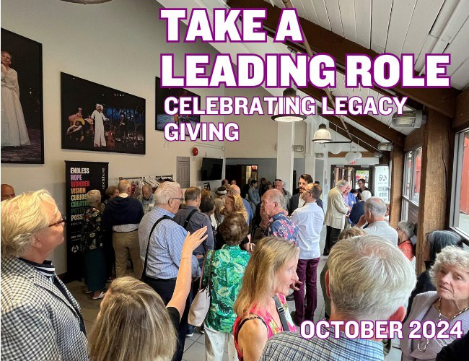

Image description: Crowd of individuals in the Granville Island Theatre lobby at a reception.

## Dear Patron,

October is Planned Giving month at the Arts Club. It’s not only a time to celebrate the incredible support we have received, but also to honor those whose generosity extends beyond their lifetime. To our major donors who have chosen to leave a gift in their will, I want to express the deepest appreciation for all who will beneﬁt from your foresight and compassion.

By including the Arts Club in your estate planning, you have made a profound statement about your belief in the work we do. You are reaffirming our mission, and the values we stand for. This type of giving is more than a donation – it is a lasting legacy that will touch countless lives well into the future creating hope, inspiring creativity, and generating potential for generations to come.

If you’ve ever considered leaving a gift in your will, Planned Giving month is the perfect time to explore how you can create a meaningful legacy. Your gift will continue to ensure the future of the Arts Club and help to create possibilities on every stage!

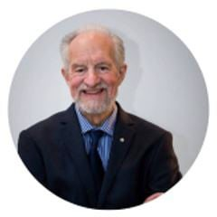A close up of a signature  Description automatically generatedThank you, from the bottom of our hearts, for your visionary support! Cheers,

Bill Millerd

Artistic Director Emeritus Honorary Chair, Legacy Circle

Image Description: Black and White photo of Bill Millerd, Artistic Director Emeritus wearing a suit.

# THANK YOU "AUNT GERRY"!

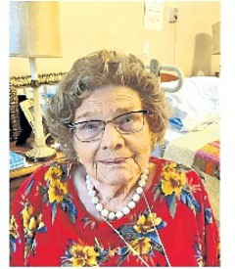

Image Description: Legacy Circle Donor, Margaret Gibb-headshot wearing a red ﬂoral dress and white beaded necklace (photo courtesy of The Vancouver Sun)

Margaret Gibb, affectionately known as “Aunt Gerry” by her nephew, was a longtime patron and donor of The Arts Club Theatre Company, and we would like to thank her for her Legacy Gift. We sincerely wish we would have had the chance to recognize Gerry in life!

Margaret passed away on September 12, 2023, at the age of 100 and we only found out about her generous Legacy Gift to the Arts Club after her passing. To honour her generosity, we connected with Aunt Gerry’s nephew to learn a little more about her life and legacy.

Aunt Gerry had an inquisitive, rich, and critical mind. For most of her career, she was a school librarian, and eventually obtained her Master’s Degree in Library Science. She was an avid bridge player and a strong devotee of the arts, including literature, plays, movies, and concerts. Her nephew recalls “Aunt Gerry often took me to plays in an effort to ‘culturize’ me.”

Gerry was active in her community, as a past president of Brock House Society, and was passionate about giving back to her community. During her early retirement, she donated her time to charities such as Meals on Wheels, and made generous ﬁnancial contributions to organizations like the SPCA.

Gerry enjoyed a variety of Arts Club productions over her ﬁfteen years of patronage, from her ﬁrst show *Evita* in 2004, to Arts Club classics *Mom’s the Word, Sexy Laundry,* and *Beauty and the Beast*,

to the ﬁnal show she attended in 2019, *Miss Bennet: Christmas at Pemberly*. Throughout these years she also supported the Arts Club as a donor to various campaigns.

Ruby Campbell, the Arts Club Planned Giving Officer, says “I wish we could have had an opportunity to meet and. thank Aunt Gerry in person for her generous gift to the Arts Club! It’s always lovely to hear what inspires someone to leave a gift in their will, to hear how the Arts Club experience has impacted their life and their families.”

For those patrons considering leaving a legacy gift, we encourage you to let us know, so we can properly recognize you in life as part of our Legacy Circle. Ashlie Corcoran, Artistic Director, shares “we are truly grateful to our donors, whose support buoys the Arts Club’s future. We always appreciate meeting them, so that we can thank them in person, and learn best how to continue their legacy.”

The Legacy Circle provides an opportunity for likeminded theatre enthusiasts to engage with each other and the Arts Club at events such as, our Donor Appreciation event, Season Launch, and Education showcases. As much as the Legacy Circle is a chance for us to thank you, it is also an opportunity for you to engage with fellow theatre lovers in your community.

If you are interested in leaving a gift in your will and joining the Legacy Circle, Ruby Campbell, Planned Giving Manager, would be happy to hear from you at [rcampbell@artsclub.com](mailto:rcampbell@artsclub.com) or 604.687.5315 ext 279

# A person wearing a hat Description automatically generatedLEGACY CIRCLE PROFILE: TEDDY FORSYTH

Image Description: Legacy Circle donor, Teddy Forsyth wearing a hat and a green top

Teddy Forsyth has been a cherished and long-standing member of the Arts

Club community for over 40 years, over which she has been an employee, patron, donor, and now a member of the Legacy Circle.

Teddy ﬁrst started working at the Arts Club in the 1980s, after graduating university, in the Box Office and Front of House. Often helping with backstage tasks at this time, she enjoyed being able to “have the full experience of creating and touching all elements of the art.”

She recalls it as a place that has always felt close to her where she was “welcomed, nurtured, and accepted.” In 1983, Teddy even had her wedding on the Arts Club’s Revue Stage on Granville Island, complete with the *I Do! I Do!* set as her backdrop. Her kids followed in her footsteps; all members of her family having worked for the Arts Club in some capacity. She sees the Arts Club as “being kind of the second home, not taking away from my home and my family, but being that other welcoming place.”

In her current position as Executive Business Manager, Teddy enjoys attending dress rehearsals, providing administrative support, and knowing that the work she’s doing is still connected to the art onstage. Some of her favourite productions in recent years have been *Onegin,* for its electric atmosphere and invigorating story of love, loss, and camaraderie and *Fun Home*, for its emotional resonance and focus on family relationships. She is passionate about the Creative Teens program, noting that in addition to creating great performances, it gives students skills for life in how to balance and ground themselves. She emphasizes “I think it's really important that people know the Arts Club is ﬁlled with people who genuinely care about what it is that they do, and they're very proud of what they do.”

When considering leaving a legacy gift, Teddy recalls speaking to former board chair and Legacy Circle member Richard Bell and realizing “it just made sense.” She sees it as “a way to say thank you for providing [her] a career in theatre for all these years”, and a chance to leave a positive lasting impact. Teddy emphasizes that every little bit helps, and no contribution is more important than another, noting “maybe you can’t leave a lot, but you can leave a little bit.”

Thank you, Teddy, for your years of service to the Arts Club and your commitment to leaving a lasting legacy and impact!

# WHEN YOU LEAVE A GIFT IN YOUR WILL TO THE ARTS CLUB....

* Children receive free drama programs at urban schools
* Youth receive playwriting mentorship and skills
* Individuals living with disabilities can access the theatre
* Artists can create new inspiring and entertaining shows
* You create a lasting legacy!

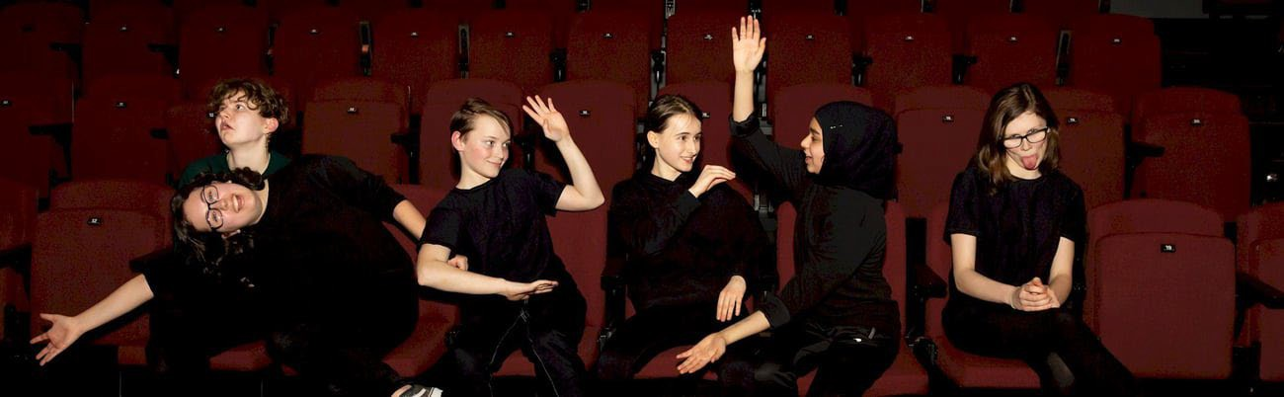

Image Description: Six youth sitting in theatre seats in different positions. Some with their hands up, one sticking their tongue out and others leaning over. all wearing black..

Once you include a gift to the Arts Club in your will, please let us know so we can include you in The Legacy Circle with other theatre enthusiasts. We love to hear from you and invite you to Arts Club events such as our Donor Appreciation party, Season Launch, and Education showcases.

If you choose to remain anonymous, we assure you that your information is kept in strictest conﬁdence.

Our sincerest gratitude to those that have joined the Legacy Circle already!

To join the Legacy Circle or for more information, please contact Ruby Campbell, [rcampbell@artsclub.com](mailto:rcampbell@artsclub.com) or 604.687.5315, ext. 279.

Image Description: Headshot of Ruby Campbell wearing a multi colour top



Image description: Bell Alliance's logo that reads "bell alliance LLP" with the text "Thank you Richard Bell and Bell Alliance Lawyers & Notaries Public for their continued support and sponsorship of the Legacy Circle program. For assistance with planning for your future, visit the Bell Alliance website for more information."



The Arts Club Theatre Company acknowledges the traditional, ancestral, and unceded territories of the [xʷməθkʷəy̓əm](https://artsclub.emlnk1.com/lt.php?x=3TxtmrUFUqPUT55qA3P3guls2XRWutH0wxc2Z5jLVXPP6sCvytE9UeVx2HBWiAFfx2c1Y5fJMnai65.K0_AYVed01n6) (Musqueam), [Sḵwx̱wú7mesh](https://artsclub.emlnk1.com/lt.php?x=3TxtmrUFUqPUT55qA3P3guls2XRWutH0wxc2Z5jLVXPP6sCvytE9UeVx2HBWiAFfx2c1Y5fJMnai65.K0_AYVed01n-) (Squamish), and [səlilwətaɬ](https://artsclub.emlnk1.com/lt.php?x=3TxtmrUFUqPUT55qA3P3guls2XRWutH0wxc2Z5jLVXPP6sCvytE9UeVx2HBWiAFfx2c1Y5fJMnai65.K0_AYVed01nA) (Tsleil-Waututh) Nations, the original stewards of this land on which we operate. We would like to ask those visiting or living here to share their thanks by supporting local Indigenous artists and communities. Acknowledging is always a start to supporting; as we step forward, we wish to be better partners, healers, and helpers to our Indigenous neighbours.

## The Arts Club Theatre Company is a not-for-proﬁt registered charity (no. 11921 3551 RR0001).

Front cover photo credit: Moonrider Productions